16.1 Petroleum
Name: ____________________ Class: ____________________ Due date: 1.13
1. Which method is used to obtain petrol from petroleum? （ ）
A crystallisation B diffusion C filtration D fractional distillation

2. Which fraction from the fractional distillation of petroleum does not match its correct use? （ ）
 | fraction | use
A | fuel oil | domestic heating
B | kerosene | jet fuel
C | naphtha | making roads
D | refinery gas | for heating and cooking
3. Which properties of the different compounds in petroleum enable its separation into fractions? （ ）
1 boiling point
2 chain length
3 chemical reactivity
4 solubility in water
A 1 and 2 B 1 and 3 C 2 and 4 D 3 and 4

4. Bitumen is a substance obtained from the fractional distillation of petroleum.
Which row describes its boiling point and the size of its molecules? （ ）
 | boiling point | size of molecules
A | high | large
B | high | small
C | low | large
D | low | small

5. The table shows some fractions that are obtained from petroleum by fractional distillation, together with some of their uses.
fraction | use
refinery gas | cooking
gasoline | fuel for cars
1 | making chemicals
2 | jet fuel
3 | fuel for ships
bitumen | making roads
Which row correctly identifies fractions 1, 2 and 3? （ ）
 | 1 | 2 | 3
A | diesel oil | fuel oil | lubricating fraction
B | fuel oil | diesel oil | kerosene
C | kerosene | naphtha | diesel oil
D | naphtha | kerosene | fuel oil
6. The table shows the composition of four different types of petroleum (crude oil).
fraction | Arabian Heavy /% | Arabian Light /% | Iranian Heavy /% | North Sea /%
gasoline | 18 | 21 | 21 | 23
kerosene | 11.5 | 13 | 13 | 15
diesel oil | 18 | 20 | 20 | 24
fuel oil | 52.5 | 46 | 46 | 38
Which type of petroleum is best for the motor vehicle industry? （ ）
A Arabian Heavy B Arabian Light C Iranian Heavy D North Sea

7. Which statement about petroleum is not correct? （ ）
A It can be separated into useful substances by fractional distillation.
B It consists mainly of hydrocarbons.
C It is found underground in many parts of the world.
D Its main use is for making lubricants and polishes.

8. The diagram shows the separation of petroleum into fractions.
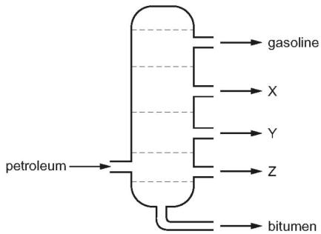
What could X, Y and Z represent? （ ）
 | X | Y | Z
A | diesel oil | lubricating fraction | paraffin
B | lubricating fraction | diesel oil | paraffin
C | paraffin | lubricating fraction | diesel oil
D | paraffin | diesel oil | lubricating fraction

9. Petroleum is an important fossil fuel.
Which row correctly describes petroleum? （ ）
 | type of substance | composition
A | compound | mainly hydrocarbons
B | compound | only hydrogen and carbon
C | mixture | mainly hydrocarbons
D | mixture | only hydrogen and carbon

10. Petroleum is separated into fractions.
Which statement is not correct? （ ）
A Each fraction contains a mixture of hydrocarbon molecules.
B Fuel oil burns easily and is used as fuel in cars.
C Refinery gas is the fraction containing the smallest molecules.
D The fractions are separated depending on their boiling point range.
11.. Some fractions obtained from petroleum are listed.
 | fraction | use | position collected in the fractionating column
1 | gasoline | waxes and polishes | below refinery gas
2 | bitumen | making roads | above kerosene
3 | kerosene | jet fuel | below gasoline
4 | refinery gas | heating and cooking | above gasoline
Which rows are correct? （ ）
A 1,3 and 4 B 2,3 and 4 C 3 and 4 only D 4 only

12. Petroleum contains hydrocarbons which are separated by fractional distillation.
Complete the following definition of a hydrocarbon.
A hydrocarbon is a compound which .........................................................................[2]
ii.Explain what is meant by the term fractional distillation.
.....................................................................................................................................
...................................................................................................................................[2]

13.Petroleum is a source of many important chemicals.
Name two industrial processes which must take place to produce alkenes from petroleum.
.......................................................................................................................................
...................................................................................................................................[2]

14.Petroleum is a mixture of hydrocarbons. It is separated into useful fractions by fractional distillation. This can be done using the fractionating column shown.
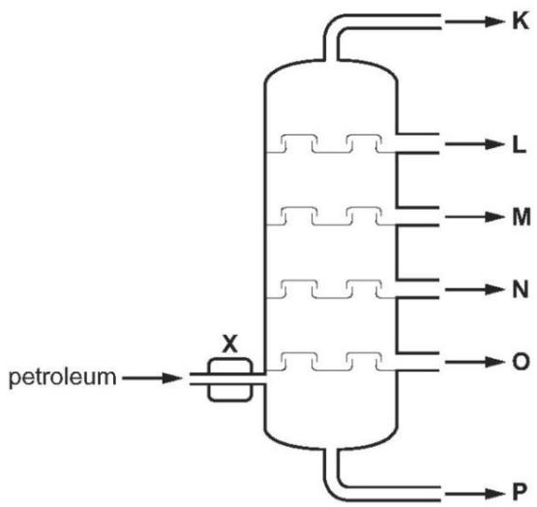
What happens to the petroleum at point X, before it enters the fractionating column?
..................................................................................................................................[1]
ii.State two ways in which fraction O differs from fraction L.
................................................................................................................................[2]

